Case Scripting Bash
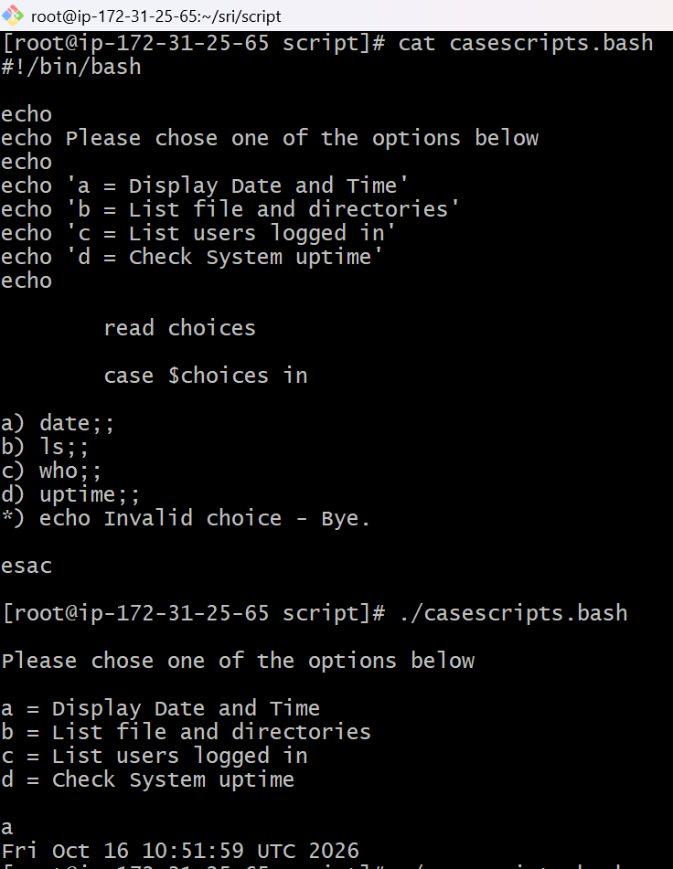
- A case statement in Bash is used to execute different commands based on the user's choice.
- It compares the input with available options and runs the matching command.
- It is useful for creating menu-driven scripts.
- 12. ./casescripts.bash — Executes the script from the current directory.
- read choices — Gets the user's choice and stores it in the choice’s variable.
- case $choices in — Checks the user's choice and selects the matching command.
- esac — Marks the end of the case statement.
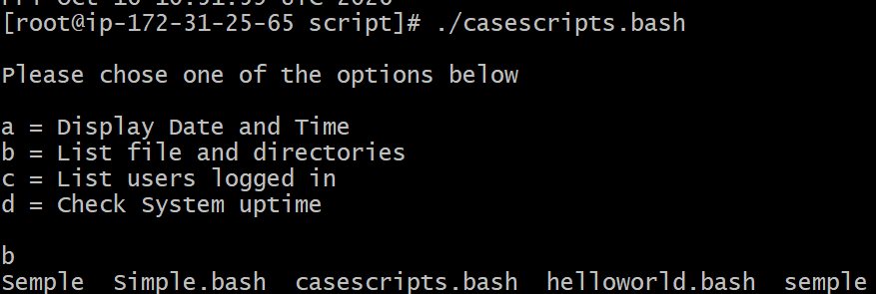
- b) ls ;; — Lists files and directories.
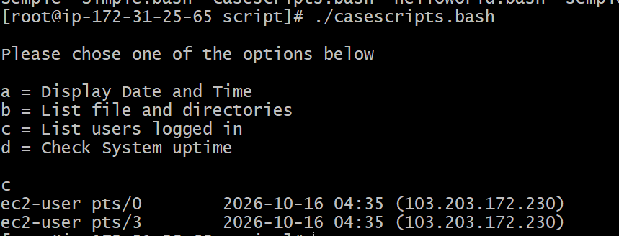
- c) who ;; — Shows users currently logged in.
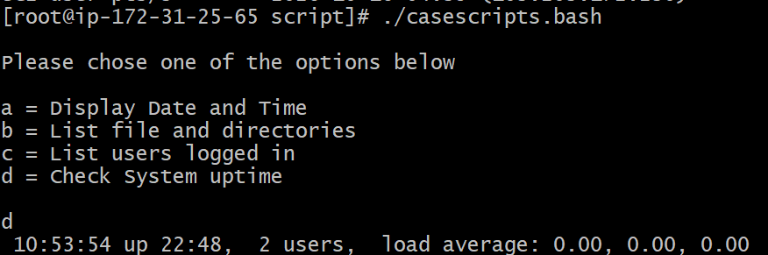
- d) uptime ;; — Shows how long the system has been running.
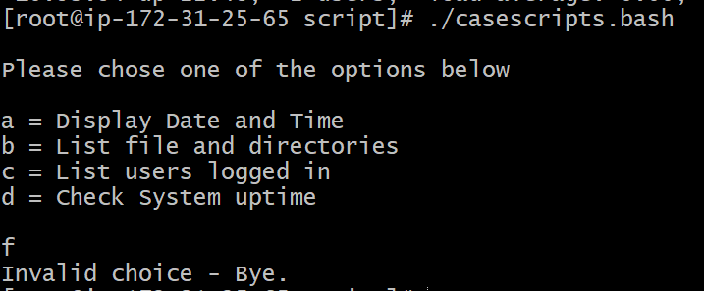
- *) echo "Invalid choice - Bye." — Displays a message if the user enters an invalid option.

Example 2. This script will look at your current day and tell you the state of the backup
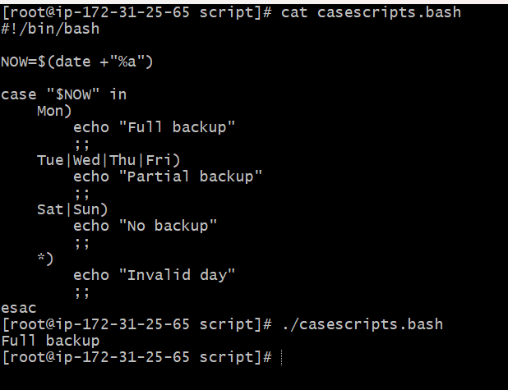
- NOW=$(date +"%a") — Gets the current day in short format, such as Mon, Tue, or Fri, and stores it in the NOW variable.
- case "$NOW" in — Checks the current day and matches it with the available options.
- Mon) — If today is Monday, displays Full backup.
- Tue|Wed|Thu|Fri) — If today is Tuesday through Friday, displays Partial backup. The | symbol separates alternative matches.
- Sat|Sun) — If today is Saturday or Sunday, displays No backup.
- ;; — Marks the end of each case option.
- *) — Handles any value that does not match the listed days and displays Invalid day.
- This means the script detected Monday as the current day when it ran.
do-while Script
- Script to run for a number of times
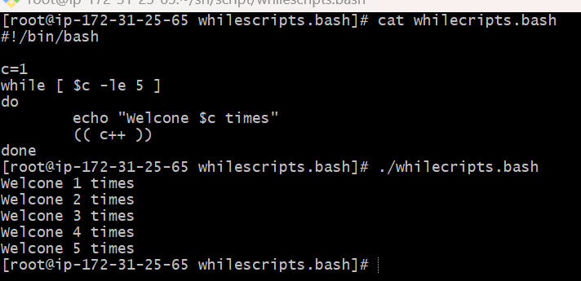
- c=1 — Creates a variable named c and sets its starting value to 1.
- while [ $c -le 5 ] — Repeats the loop while c is less than or equal to 5. The -le means “less than or equal to.”
- do — Marks the beginning of the commands inside the loop.
- echo "Welcome $c times" — Displays the message and the current value of c.
- (( c++ )) — Increases the value of c by 1 after each repetition.
- done — Marks the end of the loop. The condition is checked again before the next repetition.
- ./whilescripts.bash — Executes the script from the current directory.
- Script to run for a number of seconds
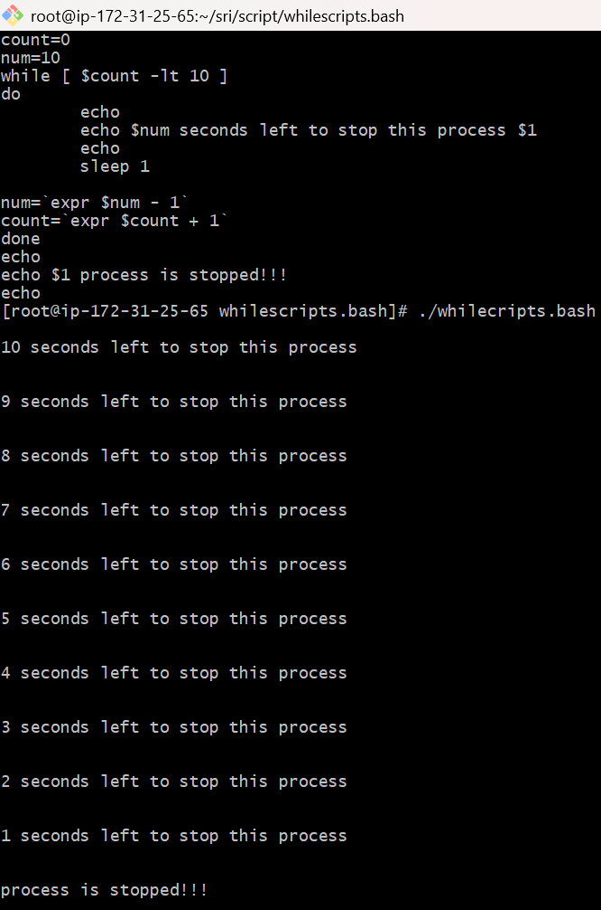
- count=0 — Initializes the counter variable to 0.
- num=10 — Sets the countdown starting value to 10.
- while [ $count -lt 10 ] — Repeats the loop while count is less than 10. The -lt operator means “less than.”
- do — Marks the beginning of the loop commands.
- echo — Prints a blank line to make the output easier to read.
- echo $num seconds left to stop this process $1 — Displays the remaining seconds and the first command-line argument ($1), which can represent a process name or other text.
- sleep 1 — Pauses the script for one second.
- **num=\expr $num - 1`** — Decreases numby1` on each iteration.
- **count=\expr $count + 1`** — Increases countby1` on each iteration.
- done — Marks the end of the loop. The condition is checked again before the next iteration.
- echo $1 process is stopped!!! — Displays a message after the countdown finishes. It does not actually stop a process
- ./whilescripts.bash — Executes the script from the current directory.

For Loop Scripts
1.Simple for loop output
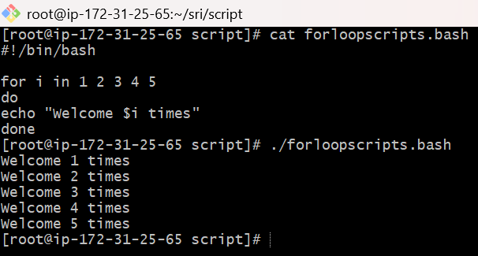
- for i in 1 2 3 4 5 — Repeats the loop for the numbers 1 to 5.
- do — Marks the beginning of the loop commands.
- echo "Welcome $i times" — Displays the welcome message with the current value of i.
- done — Marks the end of the loop.
- ./forloopscripts.bash — Executes the script from the current directory.
2.Simple for loop output
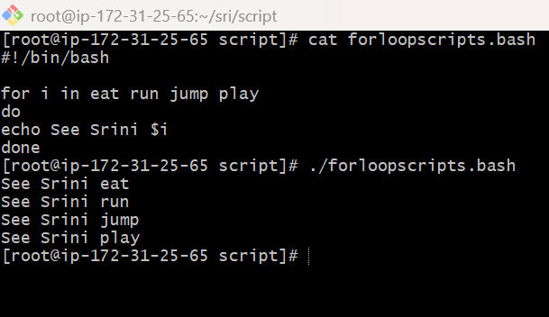
- for i in eat run jump play — Loops through the four words one by one and stores each word in the variable i.
- do — Marks the beginning of the loop commands.
- echo See Srini $i — Displays the message along with the current word.
- done — Marks the end of the loop.
- ./forloopscripts.bash — Executes the script from the current directory.

If Then Scripts
- Check the variable
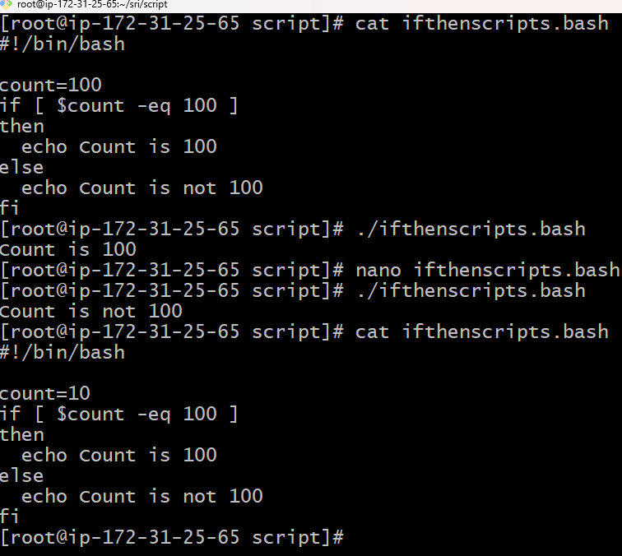
- This script checks whether the value of count is equal to 100 and displays the appropriate message.
- count=100 or count=10 — Assigns a value to the count variable. In your screenshot, you changed it from 100 to 10.
- if [ $count -eq 100 ] — Checks whether count is equal to 100. The -eq operator means “equal to.”
- then — Executes the next command if the condition is true.
- echo Count is 100 — Displays Count is 100 if the value equals 100.
- else — Executes the alternative command if the condition is false.
- echo Count is not 100 — Displays Count is not 100 when the value is not 100.
- fi — Marks the end of the if-else statement

- Check if a variable value is met

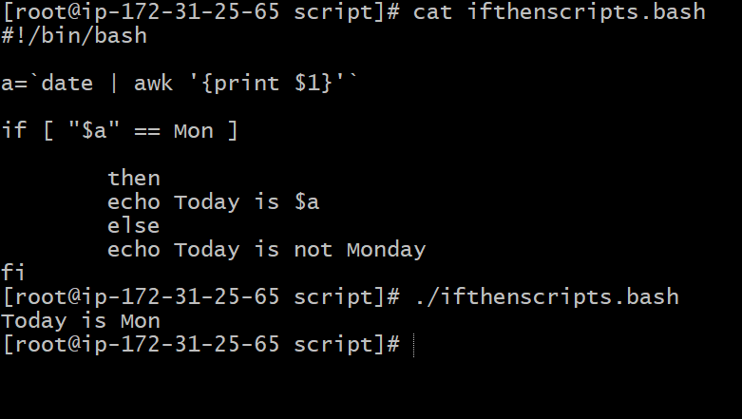
- **a=\date | awk ''`** — Gets the current day abbreviation, such as Mon, and stores it in variable a`.
- if [ "$a" == Mon ] — Checks whether the value of a is equal to Mon.
- then — Runs the next command if the condition is true.
- echo Today is $a — Displays today's day abbreviation if it is Monday.
- else — Runs when the condition is false.
- echo Today is not Monday — Displays this message if today is not Monday.
- fi — Marks the end of the if-else statement.
Crontab Bash Scripts
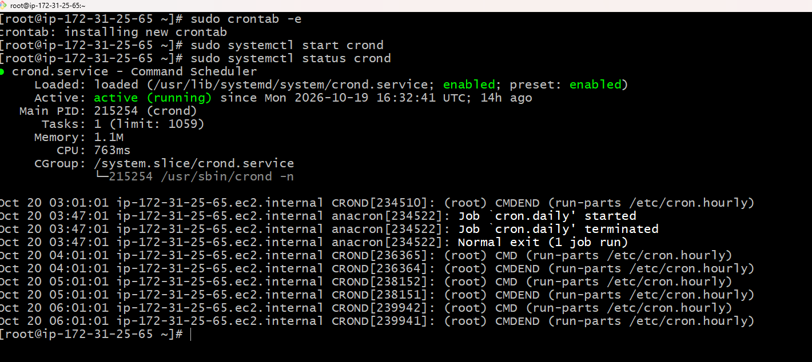
- So basically, the above screenshot shows that the crontab is installed and in actively running stage whereas we are ready to perform the crontab-based bash scripts in it.

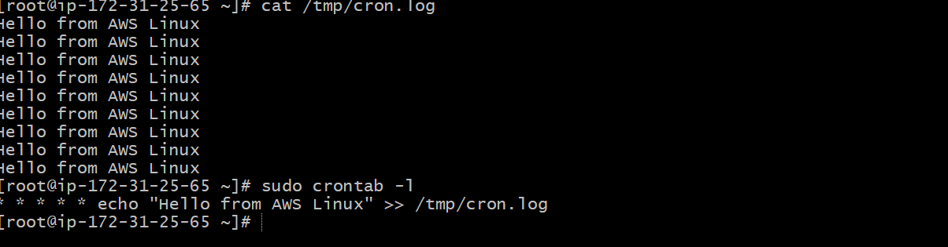
- cat displays the contents of a file.
- /tmp/cron.log is the file where your messages are stored.
- Multiple lines mean the message has been written repeatedly.
- Each execution appends a new line because your cron command uses >>.
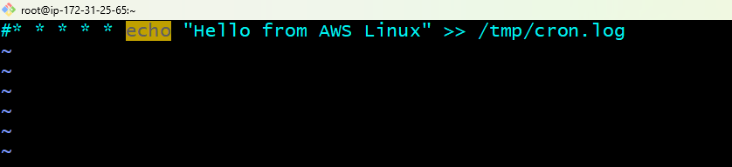
- If you want to stop this test job, run sudo crontab -e and put # at the beginning of the cron line, then save with Esc, :wq, and Enter.
- This disables only this job, not the cron service.
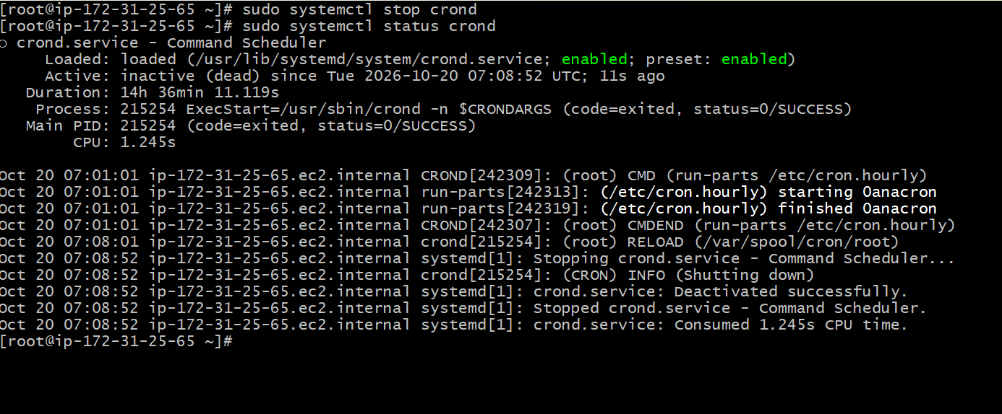
- To stop the cron service we need to disable the service using cmd sudo systemctl stop crond. This stops the complete crontab based jobs.

- Create a bash script to check if a directory is available or not.
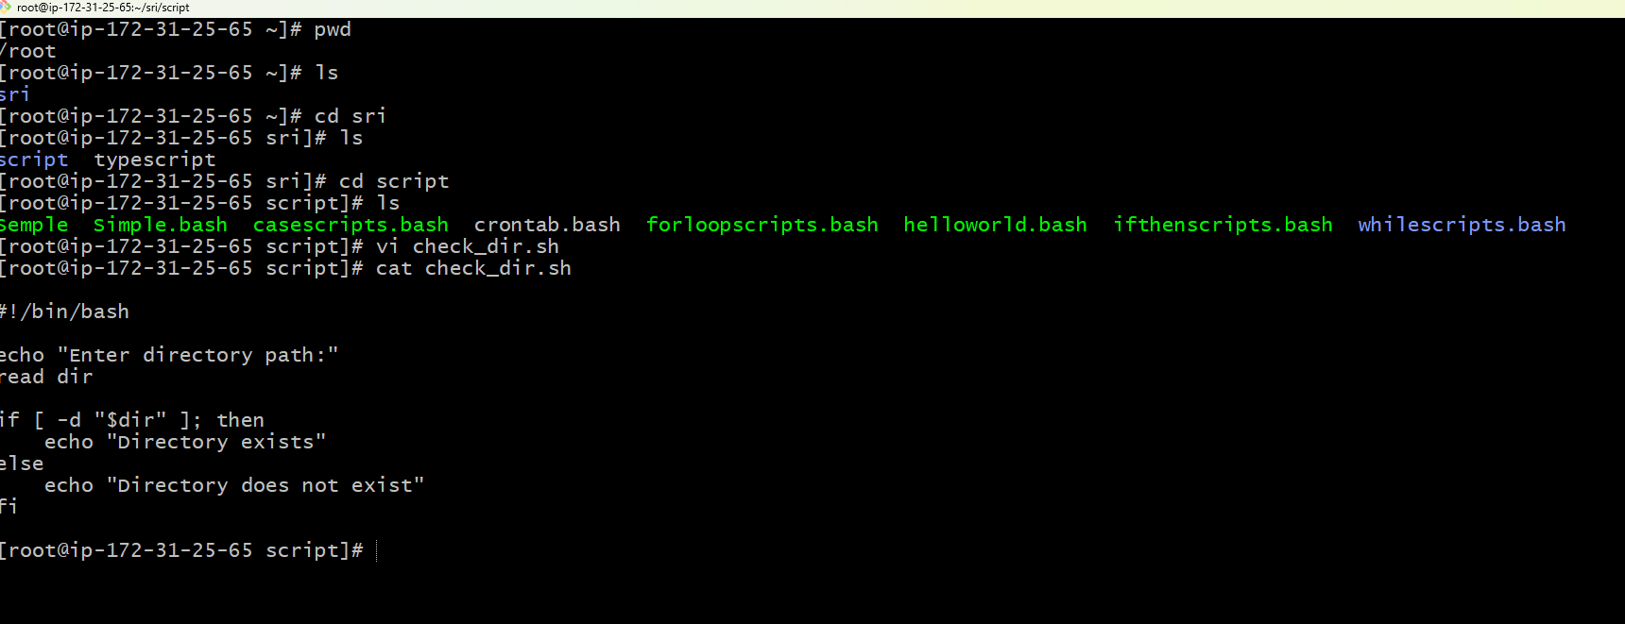
- In this we have created a file where the bash script to check directory available is going to be checked.
- There created using VI editor naming check_dir.sh and have written the bash script to check the directory available with a proper path.
- Next the permission for the file will be set with chmod 755.
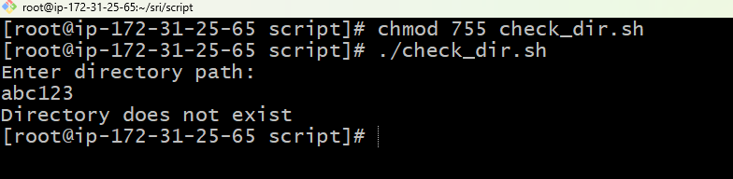
- So once we type in abc123 as path the result shown is Directory does not exist.
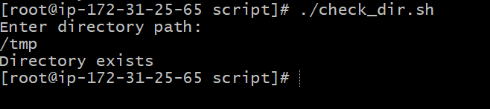
- Therefore if we type in /tmp the result shows as Directory exist.
3 Create a bash script to create multiple files.
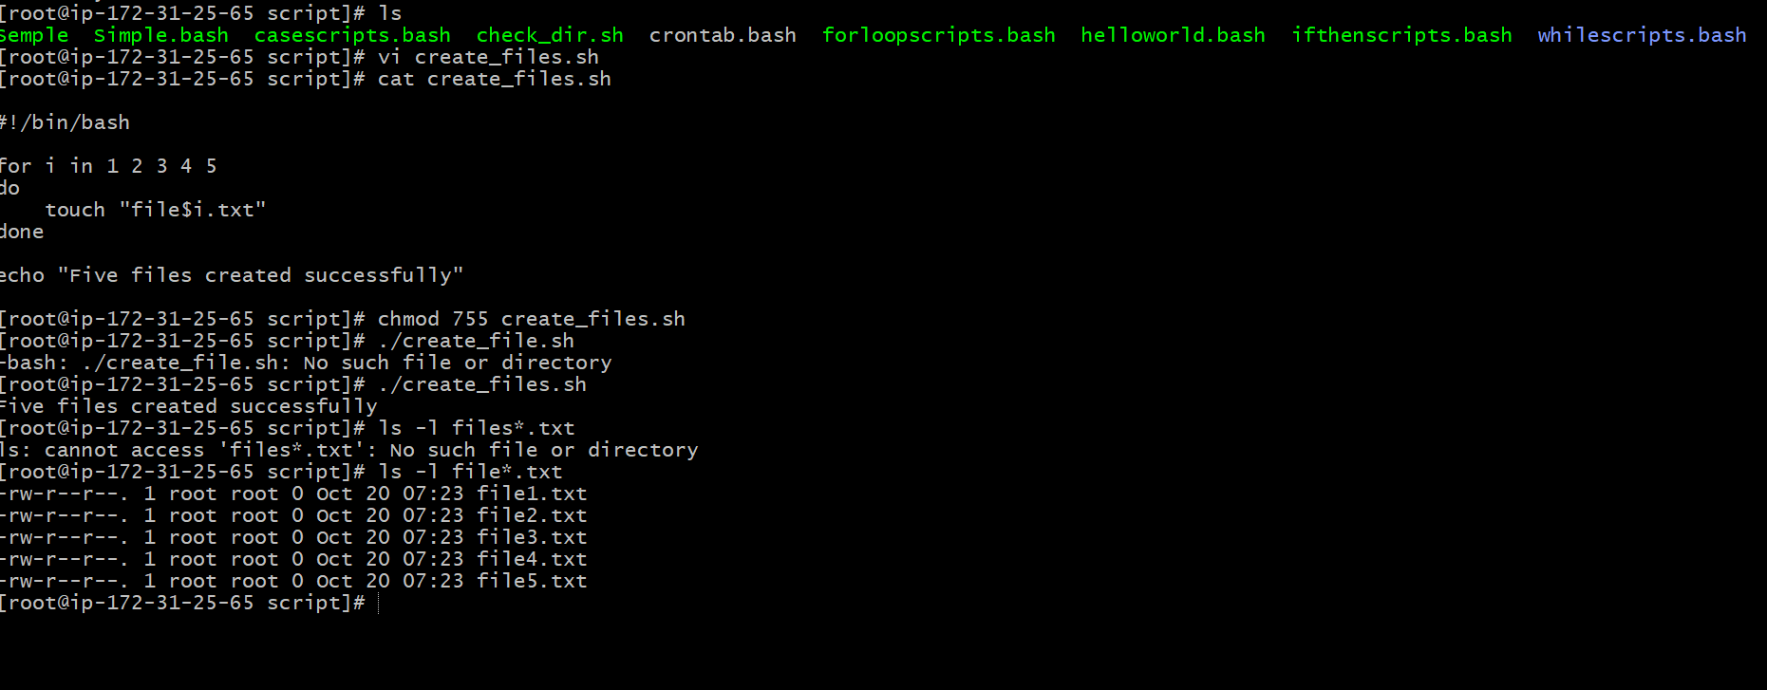
- So in this we are supposed to create no. of files using bash scripting.
- We created file to store this scripts and edits content. The file is called as check_files.sh
- Also we have entered the no. of files required to be made (5).
- 1 2 3 4 5.
- After that the permission of the file is set to 755 using chmod. Which eventually tells us that owner is allowed for all and the group is for reading and executing and same as well with others also.
- Thus by running the file using ./ we get five different files with respective names as file1, file2, file3 etc.
- Create a bash script to install Nginx on an EC2 server.
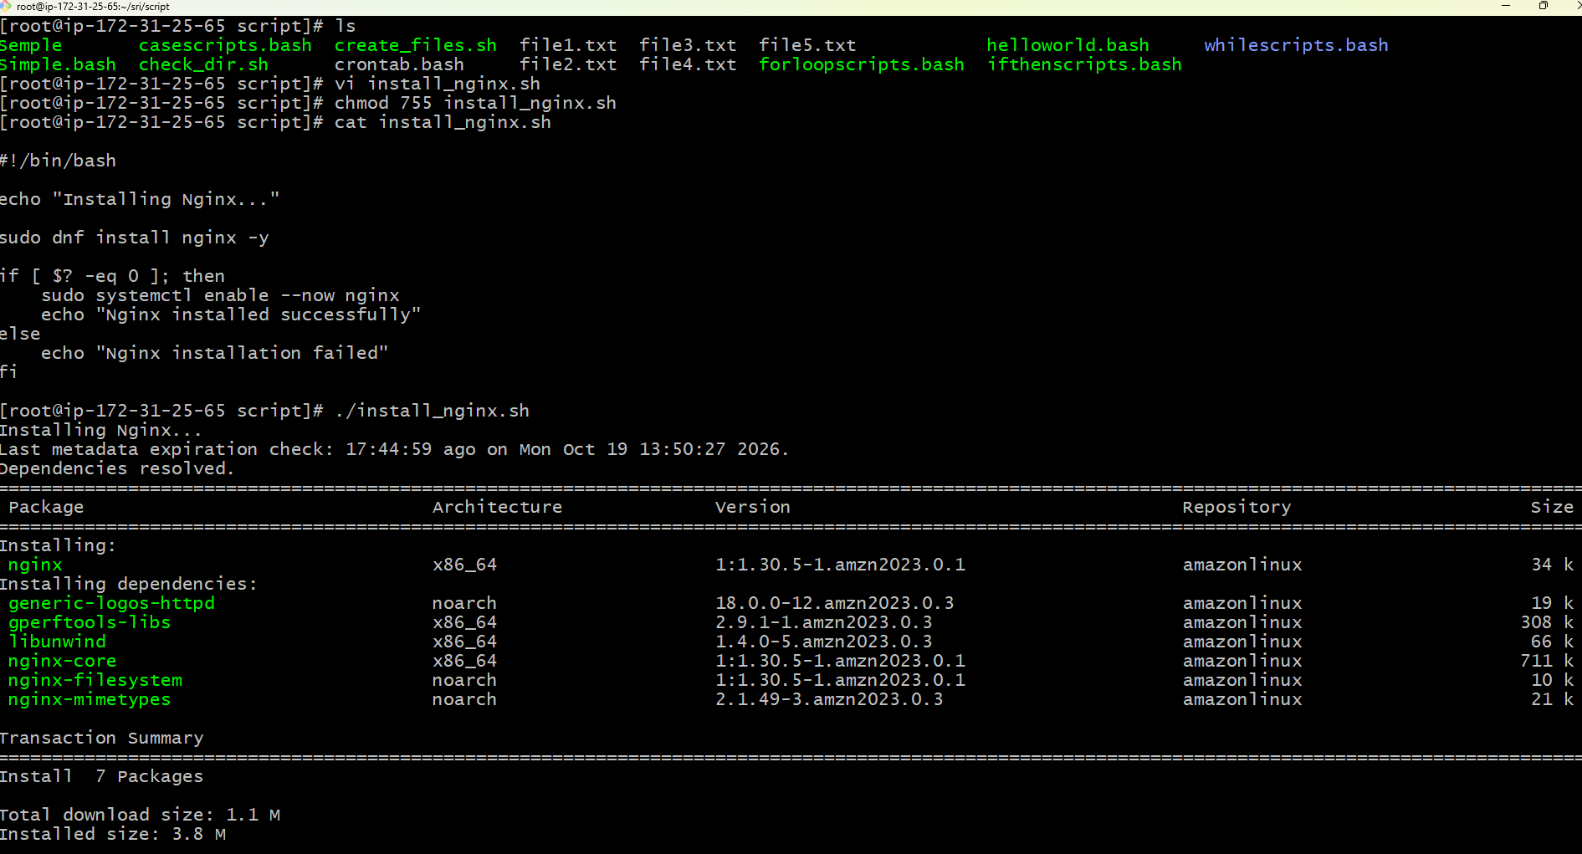
- In this we have created a file naming install_nginx.sh were we will be saving the bash scripts of installing the nginx will be stored.
- After that the vi editor has been used for editing it to indulge the script.
- After that the permission of the file is set to 755 using chmod.
- Thus by running the script we have installed and nginx is active running in our terminal.

5. Create a bash script to install Apache Tomcat on an EC2 server
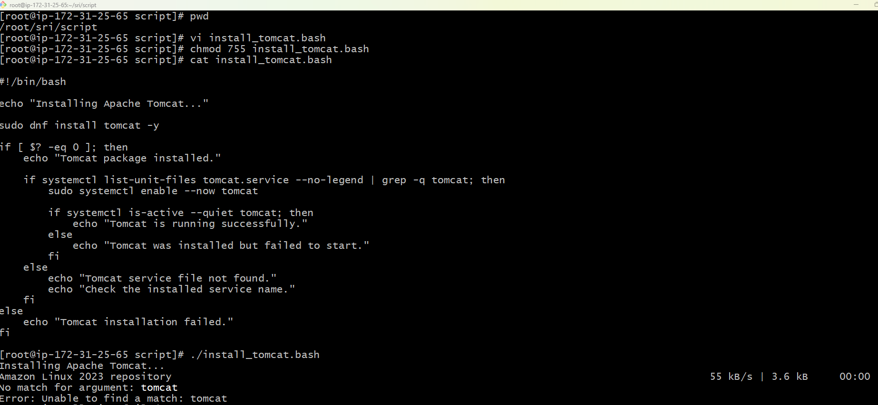
- So in this we will installing the apache tomcat service using the bash scripting.
- Therefore we have created a file which is of name install_tomcat.bash where we will be storing the scripts of the automation part for the installation is needed.
- In this there is mistake done which is in the bash script I have mentioned it as Apache_Tomcat which is to be mentioned with the version for the clarification.
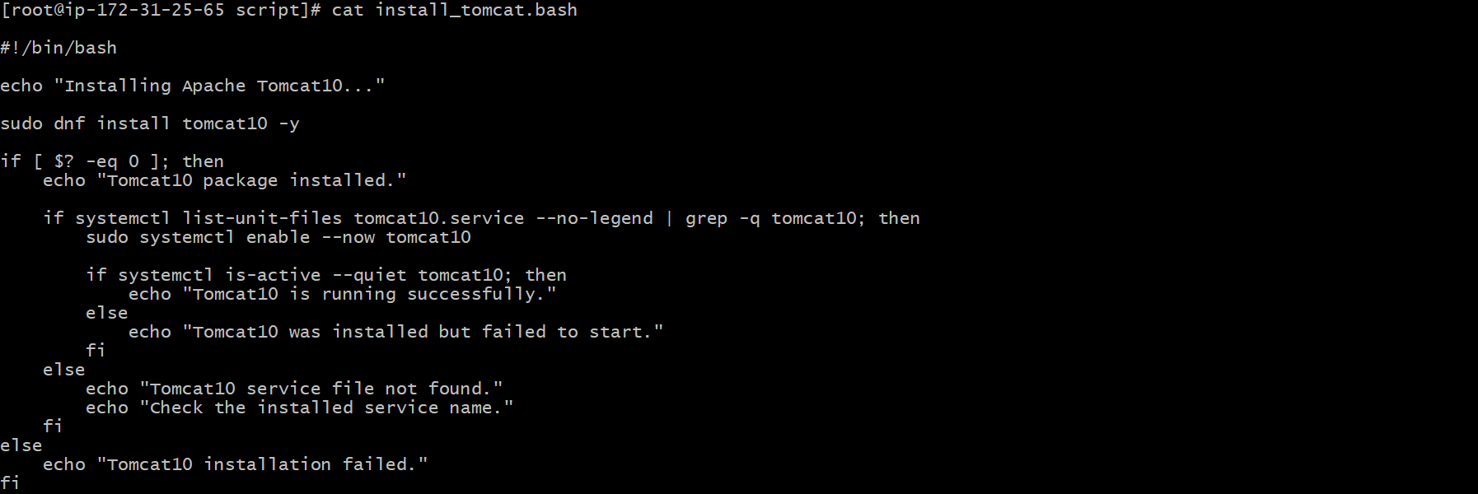
- So this is the screenshot of the corrected one in the bash scripting, which shows that wherever the tomcat is mentioned we have added 10 at the suffix of it.
- So that the linux would sense and run the commands and install the service needed.
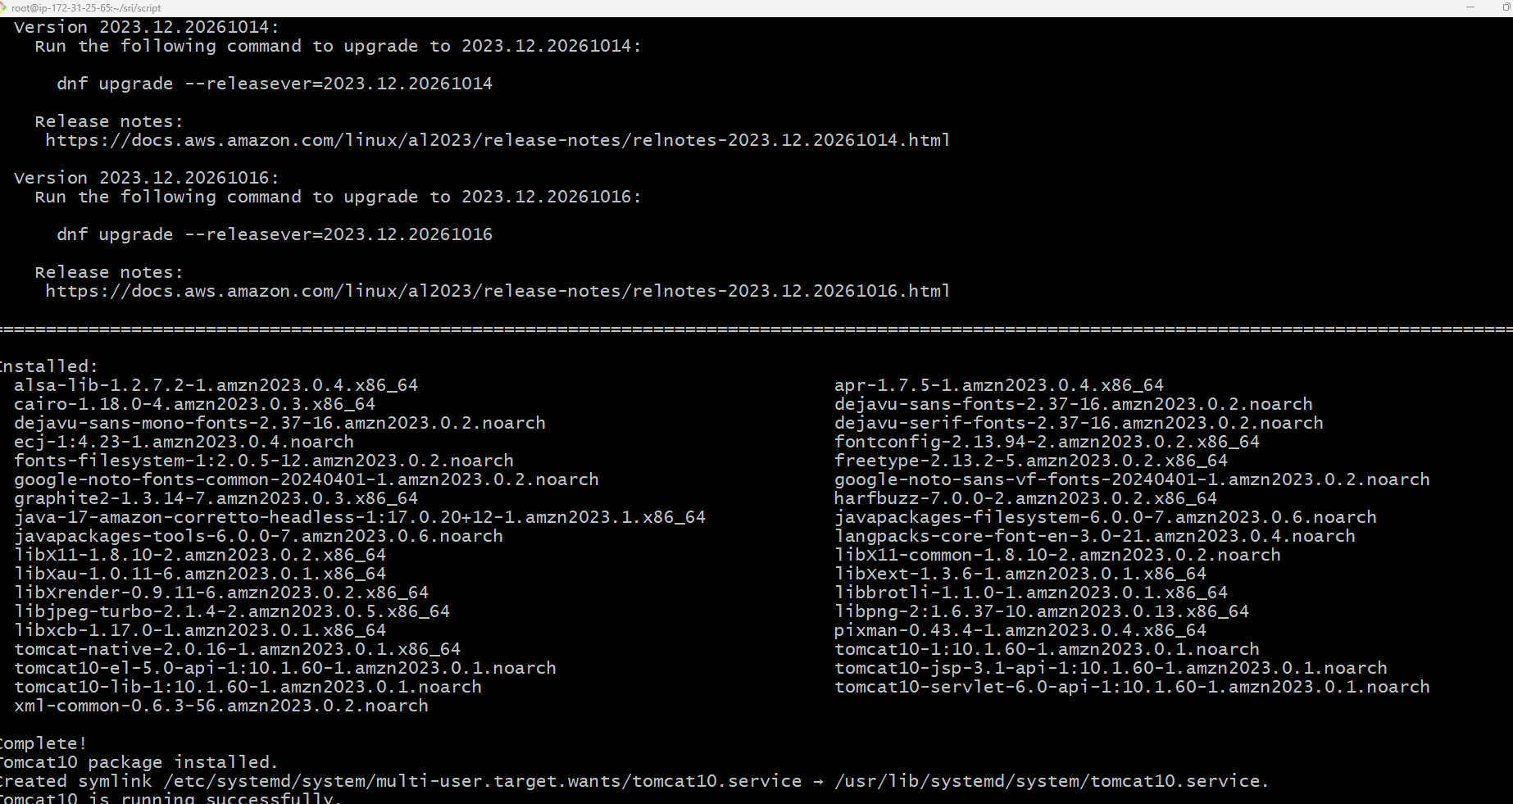
- Thus the Apache tomcat10 has been successfully installed in our ec2 instances.

- Create a bash script to check if the Nginx service is running, if not running then script should start the service.
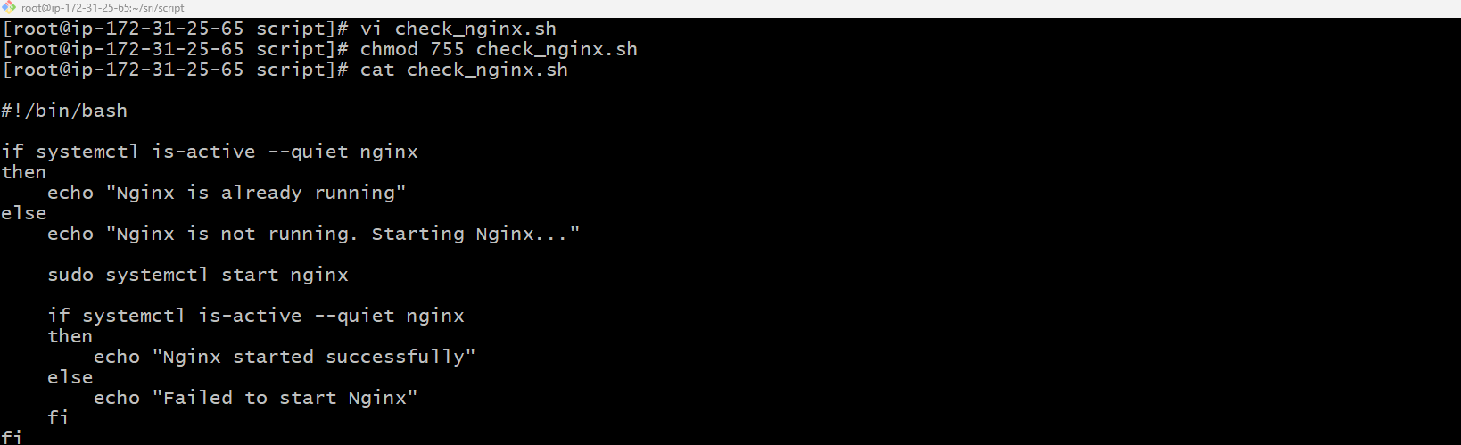
- In this we have created a file name check_nginx.sh to store the scripts for the bash in it.
- Also the permission for the file is also kept.
- Cat shows the content inside the file which we have created and scripted.
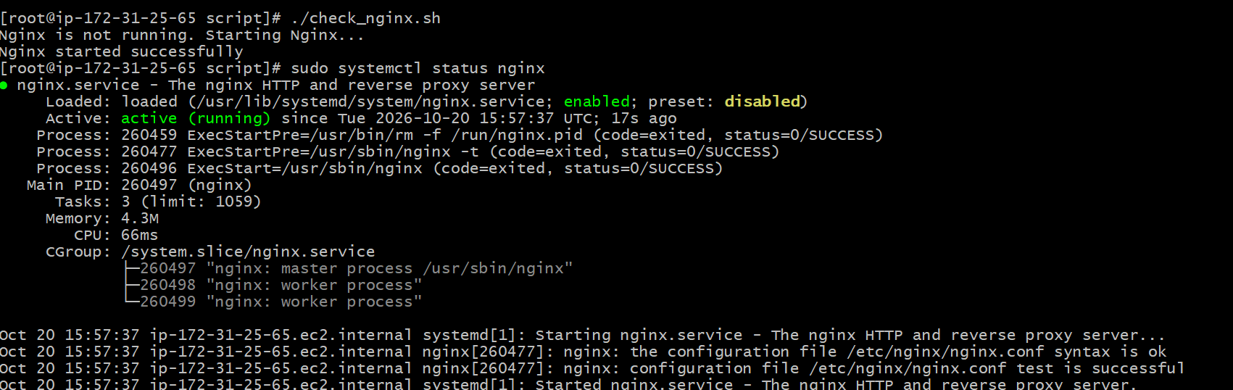
- Therefore the condition runs the nginx even if it is stopped.
- Also it shows that the nginx was in disabled condition and now it is seen as running in port 80.
- Create a bash script for a calculator.
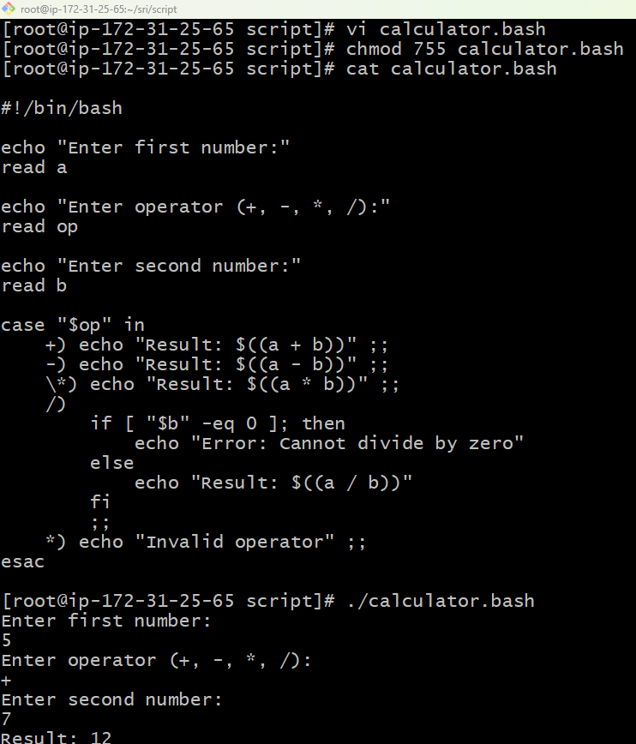
- In this we have created a calculator using bash script.
- Therefore first we have created a file using vi editor with file name as calculator.bash.
- Also we have entered the script inside it added the permission to it.
- The addition of 5+7=12 is done.
8 Create a bash script to check if a directory exists, if not then create a directory.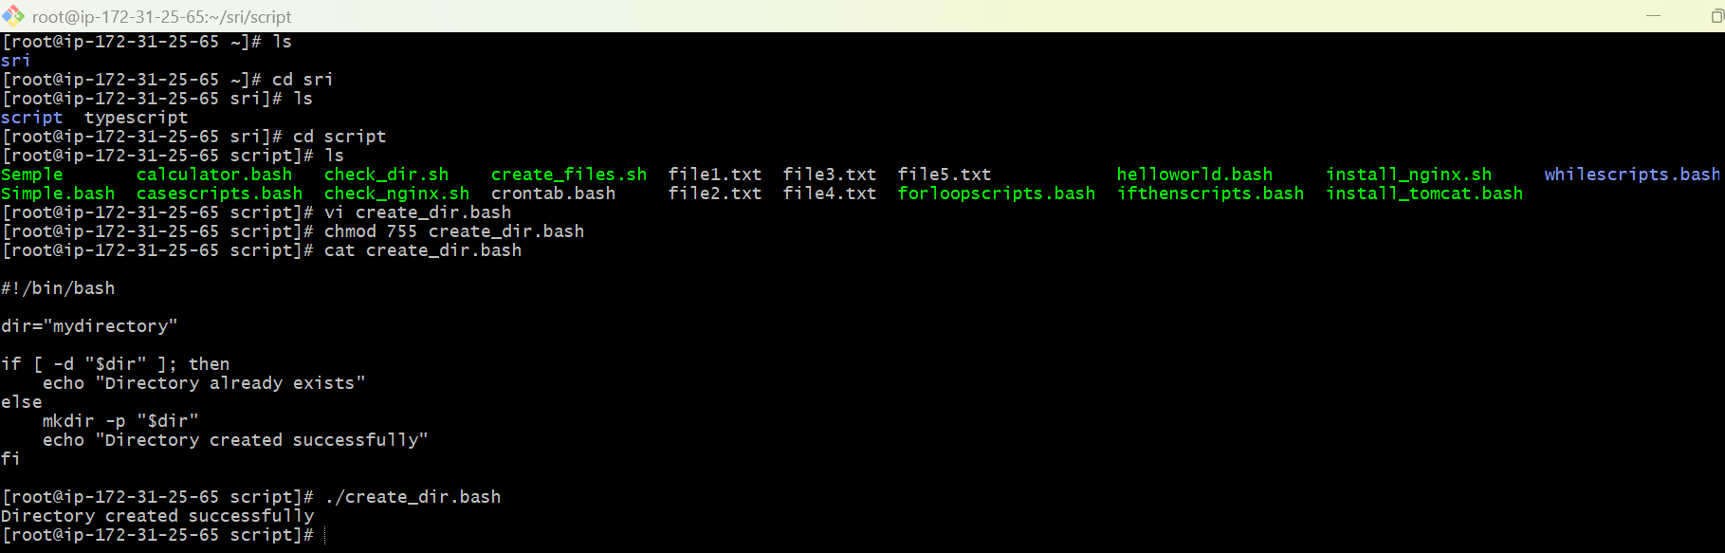
- In this we have created a check_dir.bash to check the directory is present in it.
- After that it is made in if condition which means if the condition is positive then this, if not then that.
- Permission has been allocated using chmod prompt.
- Then the script is run and the directory has been created.
- Create a bash script to delete the last 3 lines of a file.
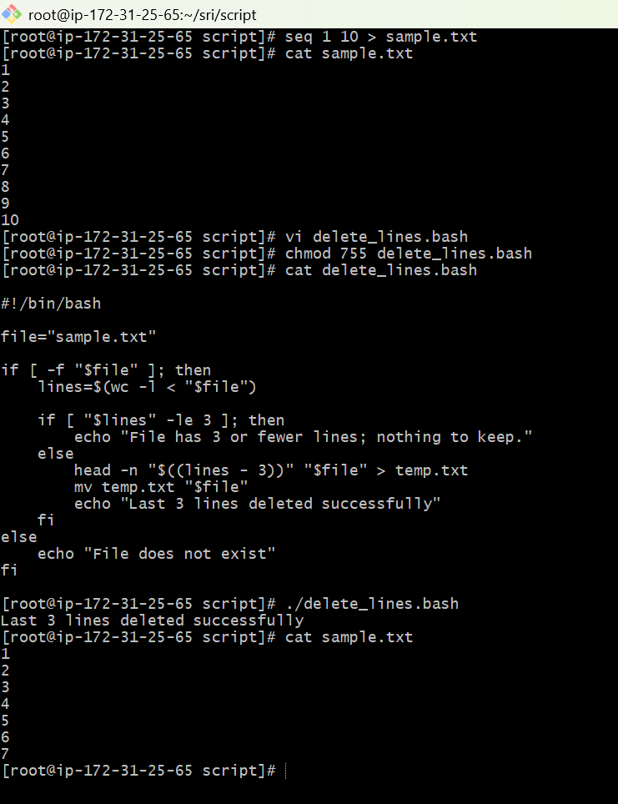
- In this we have created a file naming delete_lines.bash to store the bash script of deleting last three lines in a file.
- Therefore for that we need a sample.txt file of 10lines.
- After entering the if condition script in it the files chmod has been assigned.
- Later once after running it the last three lines such as 10,9,8 has been deleted from the file.
Exercise: Crontab Entries 1. April 5th Midnight. 2. 5th of Every November, January, June if it is a Thursday. 3. At 05 and 27th minutes of 9, 10, 11 hours every day. 4. 34 minutes of 9th hour on 15th August. 5. Every midnight. 6. Every Weekend (Saturday night 11:59 PM). 7. After every reboot.
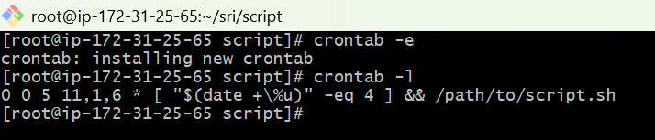
- 1 April 5th at midnight
0 0 5 4 *
- 2 5th of November, January, and June, if it is Thursday
0 0 5 11,1,6 * plus a weekday check
- At minutes 05 and 27 of hours 9, 10, and 11 every day
5,27 9,10,11 * * *
- 34 minutes past 9 AM on August 15
34 9 15 8 *
- Every midnight
0 0 * * *
- Every Saturday at 11:59 PM
59 23 * * 6
- After every reboot
@reboot

